**Final Project La Campana**

**Purpose:** Exploring areas with a specific type of oak trees that are in the correct orientation and in the correct location for samples to be augured out to use for research into the age of the tree to reconstruct the weather patterns of previous years of the trees life.

**Discussion:** The Professors from PUCV met the group at the entrance to Bienvenido Sendero National Park. The group packed the necessary tools for auguring the trees and hiked La Campana Mountain to find trees in a location that has a fair slope, and it is toward the top of the mountain to insure the rings are visible and can be easily calculated. Once the correct trees were found, each group of two received a kit to augur seven trees with 2 samples coming from each tree. A hand augur was drilled into a tree near the base until the augur was at least half way into the tree (Refer to Figure 2). The trees that needed to be sampled needed to have few blemishes and have not been damaged by fire or and human activity, so the interior of the tree was not rotten. Also, trees were chosen that had a large circumference to ensure that the tree was somewhat mature. After the augur was far enough in the tree a spoon was inserted to break away the sample from the tree and then carefully pulled out, marked, stored, and recorded. There were two samples taken from each to make sure that the data received from the sample is accurate for each tree. These samples now need to be sanded to make the rings more visible before they can be studied. The Professor from PUCV said that the trees that were sampled were most likely in the range of 50 to 100 years old (Refer to Figure 1). This means that after the samples are prepared correctly the rings of the trees can help us determine what the

weather patterns have been over the life of the tree. This information can also be used to match up similar tree ring patterns from older trees to be able to further date back the weather patterns and in the end, see whether there is a problem with the amount of rainfall and weather that needs to be dealt with so the people of Chile will have a sustainable amount of water in the future.

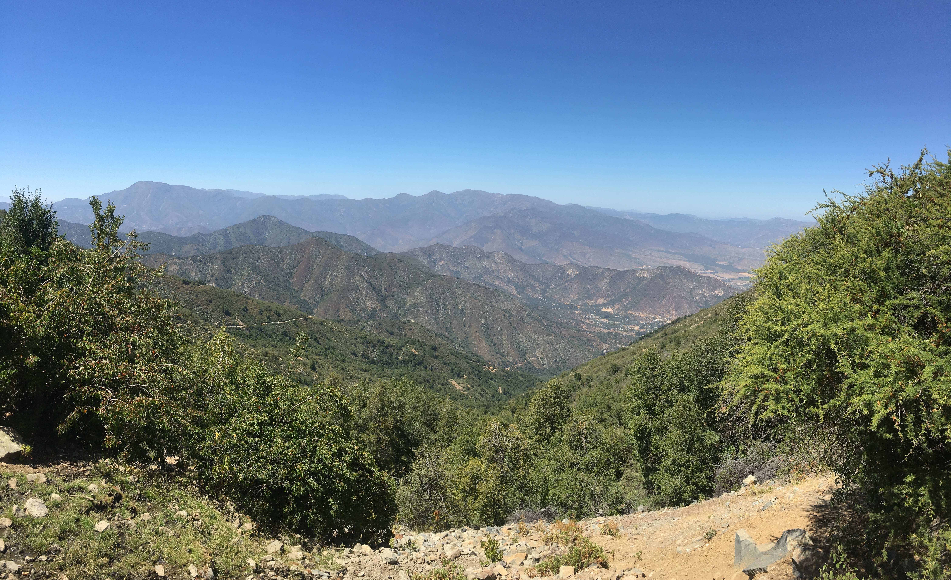

**Figure 1**

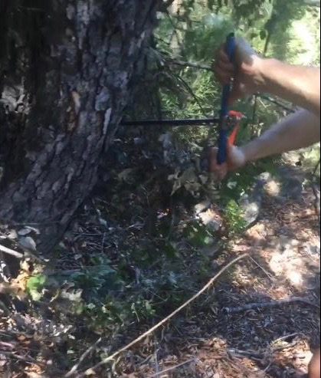

**Figure 2**

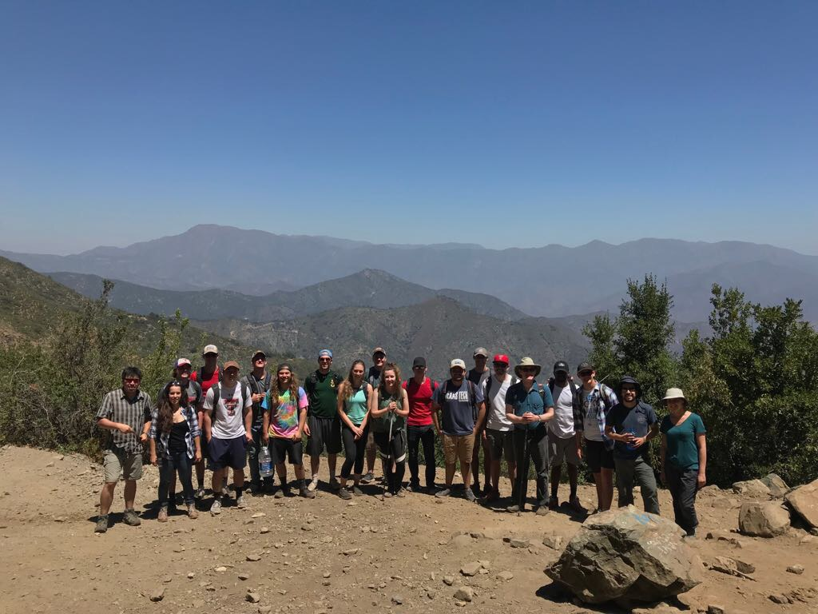

**Figure 3**

**Conclusion:** There are a lot of factors that play into getting accurate data when obtaining the samples from the trees. When I was performing the augur in the tree I noticed that the outer part of the tree sample would come out of the tree in crumbles. This brings the question is this an efficient way to obtain samples, accurately trace a trees age, and ultimately the weather patterns over the years of a trees life. While these procedures could be improved and refined the data should come out accurate enough to understand the weather patterns over a few years and determine if the weather was extreme or mild, weather there was a lot of rain or a drought. The objective of this research is not to understand one year of weather, but to understand the overall picture of the past years to predict the future. This could have impact in what steps need to be taken to insure the people, plants, and animals will continue to live in a place with necessary resources available.